3. Single-layer Linear perceptron

All functions were written. It is single layer linear perceptron with Euclidean loss. Weight slp_linear.mat containing w and b are also uploaded with the assignment. Simple single layer perceptron gives 28.1% accuracy. As per the problem, it is more than 25%. Learning rate, decay rate, decay interval and number of iterations were 0.01, 0.5, 1000 and 10000, respectively. Confusion matrix is as follows.   
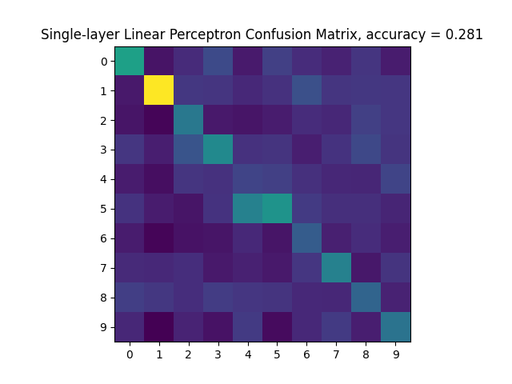

4. Single-layer perceptron

All functions were written. It is single layer perceptron with softmax cross entropy loss and relu non-linearity. Weight slp.mat containing w and b are also uploaded with the assignment. Simple single layer linear perceptron gives 89% accuracy. As per the problem, it is more than 85%. Learning rate, decay rate, decay interval and number of iterations were 0.2, 0.9, 1000 and 10000, respectively. It is better than single layer linear perceptron. Confusion matrix is as follows.   
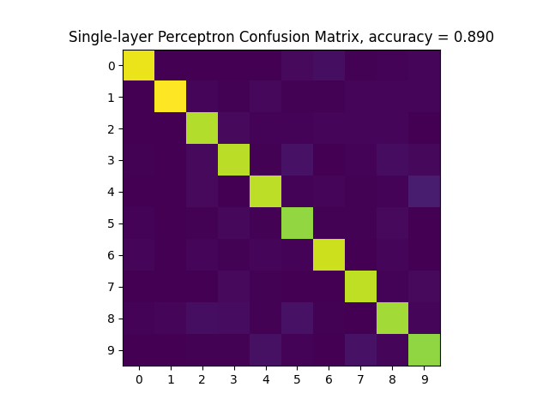

5. Multi-layer perceptron

All functions were written. It is multi-layer perceptron with one hidden layer. Weight mlp.mat containing w1, b1, w2 and b2 are also uploaded with the assignment. Simple single layer linear perceptron gives 90.1% accuracy. As per the problem, it is more than 90%. Learning rate, decay rate, decay interval and number of iterations were 0.05, 0.86, 2000 and 15000, respectively. It is better than single layer perceptron. Confusion matrix is as follows.  
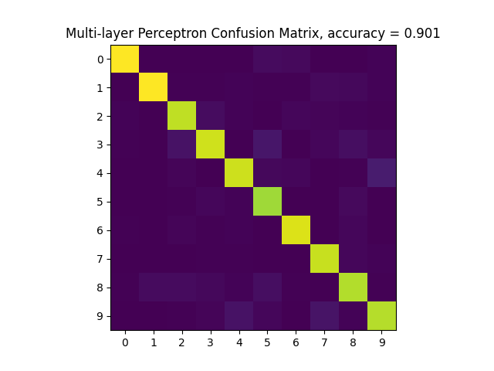

6. Convolutional neural network

All functions were written. It is convolutional neural network perceptron with filter, a maxpooling layer, a flattening layer and a fully connected layer. Weight cnn.mat containing c_conv, b_conv, w_fc, b_fc are also uploaded with the assignment. Convolutional neural network gives 93.4% accuracy. As per the problem, it is more than 92%. Learning rate, decay rate, decay interval and number of iterations were 0.1, 0.8, 1000 and 20000, respectively. It is better than multi-layer perceptron. Confusion matrix is as follows.  
